This program input is as follows:

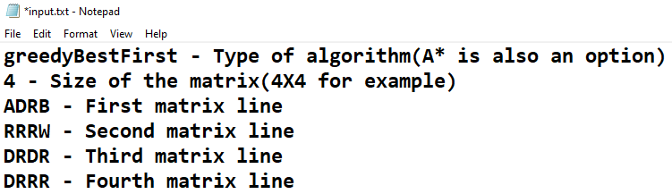

Matrix letters:

A – Starting point

B – Ending point

R – Clear road

D – Unclear road

W – Water(Blocked road)

Using R road cost **1 traveling time** and using D road costs **4 traveling time**.

The purpose of the algorithm is to find the best path from A to B with the least traveling time.

The program output is the directions the algorithm travels in the matrix in addition to the traveling time it takes.

For example:

D-R-D-D-R-R-U-L-U-U-R-13

Means the algorithm went Down-Right-Down and so on. 13 is the traveling time.